Interview code competency puzzles
P: 1300 666 274 | F: +61 3 9600 1665 | E: info@readify.net | W: www.readify.net

Introduction
Your first step in the Readify recruitment process is to demonstrate your understanding of writing code in either VB.NET or C#. You are given three mandatory small puzzles to complete, and a choice of SharePoint puzzles should you be an expert in this area. Once your code has been submitted, it will be reviewed by several code review consultants.
When writing your code, please be mindful of the following
- Your code should be production ready.
- Your code should be understandable and maintainable by other developers.
- Your code should be robust and handle error situations.
- Your code should be bug free, compile and work.
- if your code includes unit tests you may use a unit test framework of your choice (MSTest, NUnit, XUnit, MbUnit)
Code must be submitted in ZIP format (i.e. no binaries, test artifacts, etc). When you have completed your choice of puzzle(s) forward the zip file along with the other required documentation to Readify.
Good luck! And thank you for your interest in a position with Readify.

Puzzle One – Linked list
Write a function that would return the 5th element from the tail (or end) of a singly linked list of integers.
For example, given the list 2 -> 3 -> 4 ->5 -> 6 -> 7 -> 8 -> 9 -> 10 -> 11 your function would return 7.
Your code
- Should return the 5th element from the tail in a single pass.
- Should be your own code and should not use any built-in .NET collection components.

Puzzle Two - Triangles
Write a function that receives three integer inputs for the lengths of the sides of a triangle and returns one of four values to determine the triangle type.
- Scalene
- Isosceles
- Equilateral
- Error
Triangles
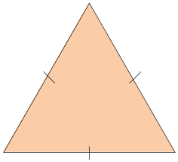 | Equilateral  Three equal sides
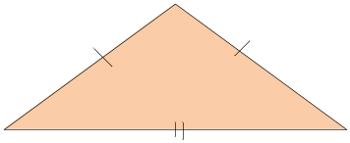 | Isosceles  Two equal sides
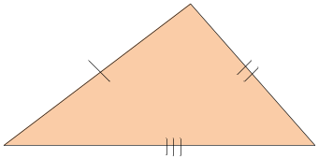 | Scalene  No equal sides

Puzzle Three – Reverse Words
Write a function to reverse the words in a string, for example “cat and dog” becomes “tac dna god”.
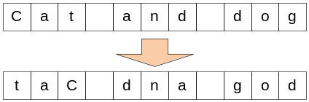
Please do not use any string manipulation functions that you do not implement yourself.
Your code
- Should reverse each word within the string without altering whitespace characters
- Should treat punctuation characters as part of the word
- Is only required to deal with standard English characters. Unicode support is not required.
- Should be your own code and should not use any built-in .NET string manipulation calls.

Sharepoint - Puzzle 1
Create a SharePoint feature that when activated, adds a new web part page to a site. This new web part page will contains 2 custom web parts. One of these web parts will show a list of 3 learning styles that a user can select from. The other web part will display a description of the learning style the user has selected. When the Visual Studio project has finished building, it should also output a SharePoint Solution Package.
Learning Style | Description
Visual learner | This type of learner needs to be able to visualise things and learns well through pictures, diagrams or handouts.
Audio learner | An audio learner will learn more easily through verbal lessons and anything that allows them to talk about what they are learning. They will often enjoy debates and discussions in class.
Kinesthetic (movement) learner | This type of person learns effectively when given the opportunity to physically interact or take a hands-on approach.

Sharepoint - Puzzle 2
Create a SharePoint feature that when activated, will create two SharePoint lists:
- Projects (Custom List)
- Weekly Reports (Document Library)
The Projects List will contain a simple list of projects. The Weekly Reports document library will have a single Content Type called “Report” with the following columns (column type is in brackets):
- Title (Text)
- Week Start Date (Date/Time)
- Project Manager (Person)
- Project Name (Lookup to Projects List)
Add the following sample Projects to the Projects List as part of the feature.
- Project Alpha
- Project Bravo
- Project Charlie
When the Visual Studio project has finished building, it should also output a SharePoint Solution Package.

